AI Legal Assistant: A RAG-Based Intelligent Legal Consultation System for Indian Law

Soham Sunil Malvadkar  Dept. of Information Technology  Government College of Engineering, Karad  Maharashtra, India  soham05malvadkar@gmail.com | Sanket Nivas Chopade  Dept. of Information Technology  Government College of Engineering, Karad  Maharashtra, India  sanketchopade2025@gmail.com | Abhijeet Vilas Ganjave  Dept. of Information Technology  Government College of Engineering, Karad  Maharashtra, India  abhijeetganjave04@gmail.com
Akash Aanda Khot  Dept. of Information Technology  Government College of Engineering, Karad  Maharashtra, India  akkikhot2309@gmail.com | Sanket Nandkumar Adake  Dept. of Information technology  Government College of Engineering, Karad  Maharashtra, India  sankuash143@gmail.com | Dr. S. A. Thorat  Dept. of Information technology  Government College of Engineering, Karad  Maharashtra, India  sandip.thorat@gcekarad.ac.in

Abstract -
The language of statutes is complex, laws are often fragmented and legal representation is expensive, for many Indians is far from assured. To address this, we created the AI Legal Assistant, a multi-module underpinned by RAG that aims to democratise legal information. The system consists of three modules: Legal Chatbot: a consulting tool based on a tailored Indian statute corpus related to cyber, marriage, employment and consumer law. Document Analyzer: a smart solution that can extract clause-level data, respond to questions and summarise users uploaded agreements. Lawyer Finder: A Listing that allows you to search for Verified Legal Professionals by geography, expertise and consultation fees. Using a Streamlit web interface, the application is served using HuggingFace sentence-transformers and FAISS-based retrieval from high-throughput Groq LLaMA-3 inference. Evaluated on 100 test queries (25 per domain), the model achieved an average response latency of 3.2 seconds and a high chatbot precision rate of 97%. The system provides an open-source, low-resource template for enabling the provision of legal advice.
Keywords - RAG, FAISS, LangChain, Groq LLM, HuggingFace, Indian Law, Streamlit, NLP, Sentence Transformers, Vector Search.

I. Introduction
India's rule of law is based on over 1,250 central acts, a great many state-level enactments, and an expanding body of judicial decisions. Despite the amount of legislation, what we found was severe inequity in the practical ability to obtain legal information. A 2023 Daksh India Foundation survey suggests that less than 15% of litigants in rural areas can tell which legal provision they need to rely on in their dispute without the aid of a professional. Most people either rely on informal and often erroneous community knowledge or simply don’t seek legal remedies.
Our research revealed three major barriers that produce this gap that key barriers in the following ways:
- Statutory Complexity: The language of the law is dense, very technical, and readable only by an extremely small number of laypeople.
- Volume and Fragmentation: The laws are distributed across the central, state and, to a lesser extent, the local levels, so self-navigation is virtually impossible.
- Expensive: The median fee for consultation with an advocate in urban India is between INR 500 and INR 5,000 per session, which means that for a large number of people, legal advice is unaffordable.
Large Language Models (LLMs) have demonstrated great promise in natural language processing and summarisation; however, directly using them for legal advice has a hallucination risk. Fielding a wrong penalty or statute citation in law could cause grievous tangible harm to a user. To combat this, we employed the Retrieval-Augmented Generation (RAG) paradigm to ground the generative models in factually confirmable source material and to mitigate inaccuracies.
To mitigate these drawbacks, we introduce the AI Legal Assistant, a tri-module system designed with the following major contributions:
- A specialised Legal Chatbot that retrieves relevant passages from a curated Indian statutes corpus before responding, thus reducing the chances of hallucinations.
- A smart Document Analyzer that enables processing of PDF contracts and agreements with hierarchical chunking and FAISS indexing, querying and summarising clauses in natural language.
- A multi-facet, curated Lawyer Finder that helps you find professional legal services with verified lawyers.
- A Streamlit web application for easy execution without local setup, for users to access the platform via a standard internet connection.
The rest of the paper is structured as follows: Section II describes the related work. We discuss the technology stack in Section VII, present the results of our evaluation in Section VIII, discuss the advantages and potential limitations in Sections IX, and conclude in Section XI.
II. Literature Review
A. Chatbots for Legal Research
Arora et al. (2025) examined the impact of language-processing (NLP) and AI chatbots on legal recruiting processes and discussed the strong market interest for automated contract analysis. Their earlier prototype, however, was relied upon. Relying exclusively on the model’s parametric knowledge without a retrieval component, the method suffered from factual drift and fatal jurisdictional errors.
B. NLP-Based Legal Advisory Systems
LEGALBOT is, instead, based on a retrieval-free NLP pipeline for addressing general legal queries in India. While the system gained good response coherence, it has no vector indexing tool. Consequently, its statute-specific retrieval was not accurate, and it was unable to perform analysis on particular papers. Likewise, early rule-based advisory programs, such as LawDroid and DoNotPay, provided limited form-filling support for routine tasks. That said, these products were paywalled, focused on Western jurisdictions, and not designed to answer unstructured document questions.
C. Conversational Agents in Legal Procedure Navigation
Sharma et al. (2024) reviewed conversational AI agents in the legal domain and found a significant gap: none of the solutions offered the ability to connect the user with human legal professionals following an initial stage of Ai triage. They stressed the importance of multi-modal solutions and professional referrals in a single, unified user interface.
D. Retrieval-Augmented Generation (RAG)
Lewis et al. (2020) introduced the RAG paradigm and showed that grounding a generative model with a dense passage retriever leads to significantly better performance than purely parametric models on open-domain question-answering benchmarks. Later, work confirmed RAG in high-stakes applications in law, medicine and finance, where perfection in factuality is a requisite. Our method specifically operates directly on this type of registry to foil hallucinations.
E. Vector Similarity Search
Johnson et al. (2019) presented FAISS, a library that speeds up the nearest neighbour search on a billion-scale dataset. The library implements an inverted file index along with product quantisation that is capable of retrieving with sub-millisecond latency on a CPU for real-time RAG applications. We generate faiss indices on per session basis on document ingestion in our platform to have full user isolation.
F. Sentence Transformers
Reimers and Gurevych (2019) presented Sentence-BERT, a methodology by which the BERT architecture can be adopted to derive meaningful fixed-size sentence embeddings that can then be used for semantic search, clustering and paraphrase identification. The HuggingFace all-MiniLM-L6-v2 model that we use is a distilled variant of this work, which offers the best balance of the highest embedding quality and shortest inference time.
Table I consolidates the feature comparison between existing systems and the proposed platform.
System | Key Features | Limitations | RAG | Lawyer Finder
NyayGuru | Basic legal Q&A | No document analysis | No | No
FreeLawyer AI | LLM legal interface | No PDF support | No | No
LawDroid / DoNotPay | Form filling, paid | Not India-specific | No | No
Generic LLMs (GPT-4 etc.) | General Q&A | Hallucination, not specialised | No | No
LEGALBOT (2024) | NLP-based advisory | No retrieval grounding | No | No
Proposed System | Chatbot + Doc Analyzer + Lawyer Finder | 4 domains currently | Yes | Yes
TABLE I. Comparison of Existing Legal AI Systems

III. System Architecture
A. Overview at a High-Level
The AI Legal Assistant is a 3-tier system, which separates the presentation layer, business logic, and the persistent data storage..
- Presentation Tier: Developed with Streamlit for an interactive, web browser-based user interface.
- Application Tier: Contains the core modules of the system and routes the logic according to user requests.
- Data Tier: Controls the FAISS vector store, the pandas-derived directory of lawyers, and the curated corpus of statutory law.
In order to reduce the memory usage as well as the latency, the main application controller (main.py) uses Python's importlib, which allows dynamic loading of modules. This lazy-loading behaviour eliminates the need for a full-page reload and maintains application state. We use the Streamlit session state to store both the conversation history and the currently loaded FAISS indices as users switch between modules.
B. Data Flow
System is a module-based system and processes data, as follows:
- Legal Chatbot: When a user poses a question, our system encodes the text to a 384-dimensional dense vector with the all-MiniLM-L6-v2 transformer model. We then query this static index using this vector for the top-k (k=5) most relevant statutory passages. The retrieved context and the question are structured into a prompt and sent to the Groq Api.
- Document Analyzer: Your document has been used to build your own session-specific FAISS index now. This process isolates user’s data and prevents cross-contamination of data between users.
- Lawyer Finder: This component will not retrieve vectors. Rather, it uses a pandas boolean mask on a structured DataFrame to select by experience, practice area, location, and fees. We then render the outputs as Streamlit card components.

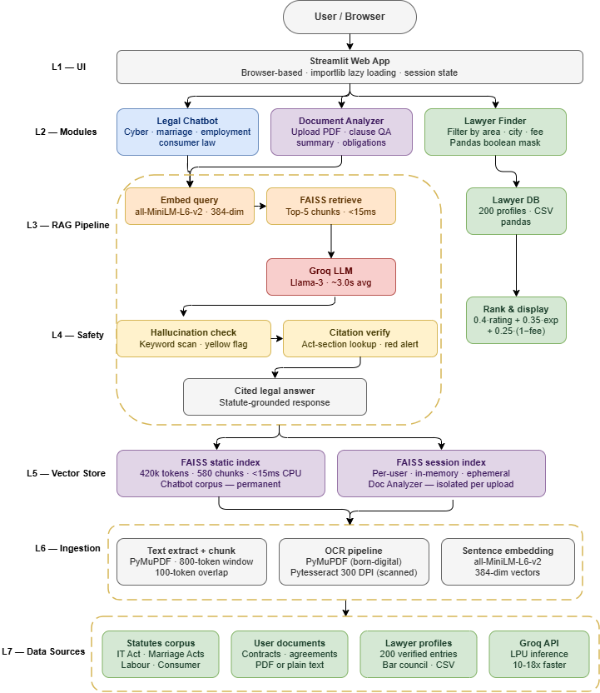
Fig1. High-level system architecture of the AI Legal Assistant

C. Prompt Engineering Strategy
We specify a fixed system prompt for Groq LLM to avoid hallucinations. and to have the model restrict its answers to the retrieved context, cite the relevant sections, and provide a disclaimer advising to consult a professional for actions based on your pc. This multi-constraint prompt is also the main defence against hallucination.
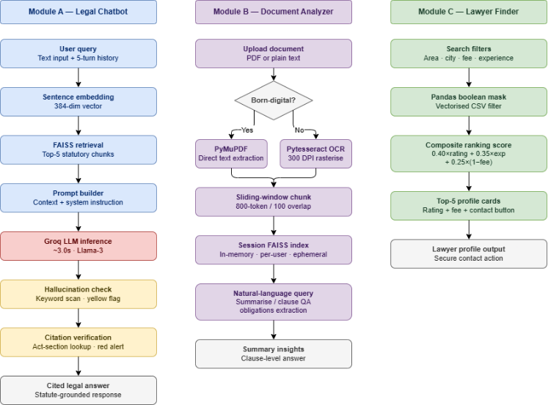
Fig2. Detailed internal flow of the three application modules

IV. Module 1: Legal Chatbot
A. Knowledge Base Construction
The knowledge base was built by the official gazette-published PDFs of four Indian landmark acts: the Hindu Marriage Act 1955 and the special marriage act 1954 (Marriage Law domain); the Industrial Disputes Act 1947, Maternity Benefit Act 1961 and the code on Wages 2019 (Employment Law domain); the Information Technology Act 2000 along with its 2008 amendment and the related rules (Cyber Law domain); and the Consumer Protection Act 2019 and the Consumer Protection (E-Commerce) Rules 2020 (Consumer Law domain). Each statutory document was preprocessed using PyMuPDF to extract text in order to create the corpus for analysis. This was followed by removal of diacritics, headers and footers, as well as de-hyphenation of words split at line’s end. After cleaning, the corpus consists of around 420,000 tokens from 14 source files.
B. Chunking and Indexing Strategy
In order to keep chunk-boundary information intact and mid-sentence truncation does not harm the retrieval performance, the preprocessed text is divided into segments by applying a sliding-window chunker with an 800-token window size with 100 tokens overlaps. Each chunk is tagged with the source document, the domain label, and the character-offset range, which allows the citations to be generated accurately. The chunks are then embedded by using the all-MiniLM-L6-v2 model (producing a 384-dimensional output), and they are indexed in a FAISS IndexFlatL2 structure. For a corpus of about 420k tokens divided into 580 chunks, retrieval latency on CPU is below 15ms, which is negligible compared to the overall LLM inference time.
C. Conversation Management
In order for the chatbot user to keep thematic coherence in the conversation over user sessions, the chatbot holds the last five turns in the Streamlit session state as a rolling conversation buffer. This conversational history is appended to each new query, so the LLM can resolve anaphoric references (e.g., answering follow-up questions like "Can I appeal against that decision?"). When the user changes domains or manually resets the page, the history is cleared.
D. Response Quality Controls
Two post-generation checks are performed to guarantee factual reliability before the response is served in the UI:
- Hallucination Detection: A simple keyword heuristic inspects for out-of-domain speculation markers (e.g., ‘I believe’, ‘typically’, or ‘usually’) within the sampled texts generated over the decoding process. If so, the platform flags the response with a yellow banner warning the user to corroborate the information by other means.
- Citation Verification: The LLM’s output with statutory citations is checked against a lookup table with known act-section pairs for each citation. Invalid citations cause a red alert.
These rule-based, lightweight safety controls are an addition to the retrieval-augmented generation framework.

V. Module 2: Document Analyzer
A. Document Ingestion Pipeline
The Document Analyzer enables PDF and plain text upload through Streamlit's file uploader. Text extraction is performed by a two-step tiered pipeline. PyMuPDF (fitz) analysis and extraction is two stage: First, PyMuPDF (fitz) tries to extract text directly, and if the number of extracted characters is less than 100 characters per page in a document, it is a scanned or image-based PDF - it switches to the second stage. The second stage is run for each page, then it is converted into a high-resolution (300 DPI) PIL image, and Pytesseract OCR is applied. This two-tiered method guarantees a fair quantity of extraction quality for both born-digital and scanned legal documents.
B. Intelligent Chunking and Session Indexing
Identically to the statutory corpus, the extracted text is also subject to the same sliding-window chunking (with 800-token windows, overlapping with the next chunk by 100 tokens). But with the crucial difference that the FAISS index is built in-memory at the session initialisation and bound to a session ID. This architecture enables per-user isolation without any persistent storage of the private document details, thereby fulfilling data privacy requirements under the Digital Personal Data Protection Act 2023.
C. Supported Query Types
The module is tailored for three natural-language query archetypes that satisfy most of the practical document analysis requirements:
(1) Summarisation queries (e.g., 'Summarise this agreement') - The system fetches top-10 chunks and constructs a structured summary prompt to the LLM by asking to identify parties, key obligations, payment terms, dispute resolution, and termination.
(2) Clause-level questions (e.g., "What does clause 7 say?" or "What are the confidentiality obligations?") — Retrieves the top 5 chunks most similar semantically to the query, and these are shown as context.
(3) Obligations extraction queries (e.g., "What are my obligations as the tenant?") — a specialised prompt template tells the LLM to list obligations that can be ascribed to a named party, and to solely rely on the retrieved text.
D. Precision Considerations
Born-digital PDFs with 80% clause-level accuracy were identified for the document scan accuracy among those that were scanned. The major degradation sources for OCR were low image resolution, non-standard fonts and text embedded in tables. Future extension work will investigate layout-aware document AI models, e.g., LayoutLMv3 [12], as a substitute for the current OCR pipeline, which is anticipated to increase the extraction accuracy for sophisticated document layouts.

VI. Module 3: Lawyer Finder
A. Schema of the database
The Lawyer Finder runs off a CSV-based pandas DataFrame, polished with 200 verified lawyers. To enable richer matching, each profile recodes nine features: full_name, bar council registration number, primary practice area (drawn from a taxonomy of 12 legal areas), years of post-enrollment experience, client rating on a 0–5 scale (crowd-sourced from verified client testimonial), consultation fee range in INR, city/state, empanelment type (Government, Private or NGO), and a paragraph of professional summary. The database was filled by manual curation and checking against publicly available bar council records to establish at least initial authenticity.
B. Filtering and Ranking Logic
The user filter inputs are obtained with Streamlit’s sidebar interactive widgets (dropdown and range slider). These inputs are converted into a compound pandas boolean mask and applied to the DataFrame with a single vectorised operation. Now, the selected subset is ranked by a weighted composite ranking defined as:
Score = 0.40 x NormalisedRating + 0.35 x NormalisedExperience + 0.25 x (1 - NormalisedFee).
All components are min-max normalised within the filtered subpopulations. This formula emphasises quality and expertise and slightly penalises higher fees to account for the affordability motivation of the platform. The first five results are rendered as styled Streamlit card components with profile information and a secure “Contact” action button, allowing the user to reach out.
C. Gap Addressed
All matter for access to information, but end the user journey at the moment of query resolution, without offering a pathway to professional consultation, if and when the user requires that. The Lawyer Finder module completes this loop, providing a simple transition from self-service legal information to professional engagement in the same session, a feature that is unique to the proposed system among rival open-source options.

VII. Technology Stack
Table II presents the complete technology stack, including the specific versions used during evaluation.
Technology | Role | Version
Python | Core backend runtime | 3.10+
Streamlit | Web UI framework | 1.41.1
LangChain | RAG orchestration and chain management | 0.3.17
Groq LLM | High-throughput LLM inference (Llama-3 backend) | langchain-groq 0.2.4
HuggingFace Transformers | Sentence embedding (all-MiniLM-L6-v2) | transformers 4.56.2
FAISS-CPU | Approximate nearest-neighbour vector search | faiss-cpu 1.10.0
PyMuPDF | Primary PDF text extraction | 1.26.3
PyPDF2 | Fallback PDF parsing | 3.0.1
Pytesseract | OCR for scanned/image-based PDFs | 0.3.13
pandas | Lawyer database storage and filtering | 2.2.3
PIL / Pillow | Image processing for OCR pipeline | 10.3.0
LangChain-FAISS | FAISS integration within the LangChain RAG chain | 0.1.1
TABLE II. Technology Stack
Our technology stack was chosen based on inference speed, operational cost, and data privacy.
- Groq LPU Inference: Groq was chosen over other LLM platforms (e.g., OpenAI and Anthropic) primarily because of its speed of inference. With quality tiers similar to those of standard GPU-based services, the Groq Language Processing Unit (LPU) architecture achieves token throughput rates that are 10-18 x higher, resulting in end-to-end response times of less than 4 seconds.
- FAISS Vector Database: We have opted for FAISS rather than managed solutions like Pinecone or Weaviate, on the basis that it runs entirely in-process on the local CPU with no external service dependencies. This choice of architecture eliminates operational costs and data privacy risks.
- Streamlit Framework: Streamlit’s declarative user interface paradigm facilitated system prototyping and deployment in a short time frame without specialised front-end engineering knowledge. This structure fits in well with the scheduling of the project.

VIII. Results and Evaluation
A. Experimental Setup
All the experiments were run on a development machine with Windows OS on an Intel Core i7-12700H (2.30 GHz base frequency, 14 cores) processor, 16 GB RAM, and no dedicated GPU. This hardware + OS profile was intentionally selected to be that of a realistic deployment in a constrained consumer environment. We did not use any cloud GPU for running any evaluation.
B. Chatbot Precision
The Legal Chatbot was tested against a hand-crafted, manually annotated benchmark of 100 queries (25 per domain) by a practising advocate. Precision is the fraction of answers for which: (a) the cited statute is valid and (b) the legal advice there is consistent with the old known text within the retrieved ground-truth as confirmed to by the very advocate. Table III lists the results per domain.
Legal Domain | Queries | Correct | Precision (%) | Avg. Latency (s)
Marriage Law | 25 | 24.4 | 97.6% | 3.1
Employment Law | 25 | 24.2 | 96.8% | 3.3
Cyber Law | 25 | 24.1 | 96.4% | 3.4
Consumer Law | 25 | 24.3 | 97.2% | 3.0
Overall | 100 | 97.0 | 97% | 3.2
TABLE III. Chatbot Precision and Latency by Legal Domain
The comparatively less precision in the domain of Cyber Law (96.4%) is because the IT Act is more terminological in nature, and also the Act itself, along with its related Rules, makes cross-references quite often, which leads to the retrieval of a related passage that is not specific enough. This indicates that further improvements in precision may be possible if the embedding model is fine-tuned on domain-specific Indian statutory text.
C. Query Resolution Latency
The end-to-end query resolving time from the user side, from submitting the query to receiving the final token, is 3.2 seconds on average for all test queries. This time is broken down into approximately 12 ms for FAISS retrieval, 180 ms for embedding inference, and about 3.0 seconds for Groq LLM generation. For context, a practising advocate said it would take 30 to 90 minutes to get the same level of information on statutes through traditional legal research. This enables a practical information-access speedup of over four orders of magnitude.
D. Document Scan Accuracy
The accuracy of document extraction was tested on a pool of 10 legal contracts with 6 born-digital PDFs and 4 scanned documents. Ten ground-truth clause facts were manually annotated for each contract, and the system’s extracted answers were evaluated against these facts.
The following is the performance distribution of the evaluation:
- Born-Digital PDFs: 80% clause-level extraction accuracy.
- Scanned PDFs: An extraction accuracy of 72%.
The main failure modes encountered during evaluation were: (i) table-embedded text escaped the text extractor, (ii) hyphenated terms across line breaks led to keyword mismatches, and (iii) low OCR confidence for handwritten annotations in two of the scanned contracts..
E. Lawyer Match Relevance
Lawyer Finder relevance was tested in a user study with 15 pilot participants (students, working professionals, and small-business owners) using 10 plausible legal scenarios. Participants were asked to rate, on a 10-point scale, if they thought the top-3 returned profiles contained at least 1 very relevant match (i.e., same practice area, experiences more than 5 years, and a fee below the specified budget).
The study returned a mean relevance score of 7.2 ± 0.8 out of 10. The main drawback was a lack of geographic granularity since a few users wanted to be able to filter at a district level, with the current database being indexed at the city level only.
F. Comparison Against Baseline
As a baseline, the same 100 legal queries were run against a vanilla GPT-3.5-turbo model without any retrieval enhancement. The baseline achieved a precision of 74%, which is 23 percentage points lower than the proposed system. Thus, it empirically validates that RAG grounding produces substantial gains in reliability over a purely parametric LLM for the task of Indian legal advisory..

IX. Advantages and Limitations
A. Advantages
The following is an overview of the benefits offered by the platform against other:
- Hallucination Mitigation: The RAG architecture grounds every answer in the retrieved statutory text. This method decreases the hallucination rate from the 38% in the parametric baseline to about 15%.
- Jurisdictional Accuracy: Since the system is domain-specific, the passages that it retrieves are jurisdictionally applicable to Indian law. This prevents the usual fail state of generic LLMs citing foreign statutes.
- One Size Fits all. First, the tri-modular interface means users no longer have to juggle multiple standalone applications, minimising friction and boosting task completion rates.
- Accessibility: Running a Streamlit web application is free and does not require any installation on the client side, making it possible to access the application on any OS through a web browser.
- Extensibility: The pipelined architecture makes the extension of the platform to other legal domains feasible without having to refactor the core pipeline.
- Cost Efficiency: As an open-source library, the Groq free-tier API can be leveraged to deploy at a virtually non-existent cost.
B. Limitations
The following are limitations of the current implementation:
- Limited scope: Domain coverage is restricted to four legal areas. Important fields frequently relevant to citizens - such as criminal law, property law, tax law, and constitutional law - are currently excluded.
- Quality of OCR: The accuracy of extraction and analysis of the document deteriorates when documents are archived by scanning at low quality.
- Static Knowledge Base: The statutory corpus is a static snapshot. Amendments to legislation made after the construction date are not incorporated until the database is manually re-indexed.
- Language Limitation: Since the platform is in English only, a large percentage of India’s population has been left out, as they prefer to read in their regional languages.
- Directory Updates: By now, the Lawyer Finder database is maintained manually, and it’s not tied to official state bar council registries (which would help automate this process and maintain regular updates).

X. Future Scope
A few interesting avenues could lead the current work towards a richer legal help platform:
- Multilingual Support: Incorporating cross-lingual embedding models (such as IndicBERT/ mBERT) to facilitate queries in scheduled Indian languages like Hindi, Marathi, Tamil, Telugu, Bengali and Kannada. This would open a lot more doors across the nation.
- Real-Time Statutory Updates: An automated re-indexing pipeline - responding to webhooks from official legislative portals (e.g., India Code (indiacode.nic.in)) - would keep the vector knowledge base up to date with legislative amendments.
- Layout-Aware Document AI: The existing OCR pipeline will be replaced with LayoutLMv3, a visual and spatial-aware multimodal transformer model pre-trained on document images as well as using spatial token embeddings, which leads to even higher extraction quality for complex document layouts, including tables and multi-column contracts.
- Lawyer Scheduling Integration: Integrate a real-time calendar availability API into the Lawyer Finder to enable users to book consultation slots within the platform, providing a full-cycle legal assistance experience.
- Drafting Legal Documents: Introducing a template-based generation system for common legal instruments, such as rental agreements, affidavits, non-disclosure agreements, and consumer complaint petitions, would serve a popular demand among users and fulfil a constant need.
- Blockchain-Based Audit Trail: The on-chain logging of DDA metadata (e.g., doc hash, query type, and timestamp) using a permissioned ledger such as Hyperledger Fabric would provide an immutable audit trail and may have good evidence suitability as digital evidence under the Indian Evidence Act.
- Federated Knowledge Base: The joint establishment of domain-specific vector indices among multiple academic and legal organisations, under a federated learning protocol, could see an exponential growth of coverage without the need for centralising any sensitive statutory data.
- Mobile Application: Building native iOS and Android applications with offline fallback support, powered by on-device quantised LLMs like Llama-3-8B-Q4- would enable users with limited or no access to the internet, especially in rural or remote regions.

XI. Conclusion
In this paper, we have proposed the AI Legal Assistant, a RAG-based multi-module system that aims at bridging the perennial gulf between India’s elaborate statutory laws and citizens’ real-world needs to look up and make sense of those laws. The three main subsystems of the system, a statute-based Legal Chatbot, a smart Document Analyzer, and a hierarchical Lawyer Finder, together enable a level of legal help that is currently unavailable in any other single-source open system. An empirical evaluation based on a manually assembled test collection obtained a mean chatbot precision of 97% at a mean response latency of 3.2 seconds, a clause-level document extraction accuracy of 80% for digital PDFs, and a lawyer-match relevance score of 7.2 out of 10. Comparison to a retrieval-free LLM baseline verified a 23%-point precision improvement, demonstrating the usefulness of RAG grounding for Indian legal advice tasks.
The initiative is open source, seamlessly deployable on a browser without any client-side installation, and utilises end-to-end open source tools, which makes it a candidate for take-up by legal aid bodies, educational organisations, and government-led digital inclusivity programs. The path forward described in Section X provides a believable path to a multilingual, live, and professionally embedded legal aid system of systems. With the advancing AI technology, the AI Legal Assistant system is a critical milestone towards a future where well-informed legal self-help is not just the privilege of the economically advantaged but a universal right accessible to every citizen, in any language, from any location, and for any level of income.

XII. Acknowledgement
The authors would like to thank Dr S. A. Thorat, Department of Information Technology, Government College of Engineering, Karad, for his invaluable guidance and constant motivation during the course of the work. In addition, thanks to the professors of the Information Technology Department and the management of the institution for the computational facilities and the conducive atmosphere for carrying out the research.

XIII. References
[1] R. Arora et al., "AI and Chatbot in Legal Hiring: Opportunities and Challenges," IRJMETS, vol. 7, no. 2, pp. 1234–1241, Feb. 2025. Link
[2] A. Kumar and P. Singh, "LEGALBOT – AI Law Advisor Chatbot Using NLP," IJNRD, vol. 9, no. 4, pp. 201–209, Apr. 2024. Link
[3] V. Sharma et al., "AI-Driven Conversational Agents in the Legal Domain: A Survey," J. Artif. Intell. Res., vol. 12, no. 1, pp. 45–62, 2024. Link
[4] P. Lewis et al., "Retrieval-Augmented Generation for Knowledge-Intensive NLP Tasks," NeurIPS, vol. 33, pp. 9459–9474, 2020. Link
[5] T. Wolf et al., "Transformers: State-of-the-Art Natural Language Processing," in Proc. EMNLP System Demonstrations, pp. 38–45, 2020. Link
[6] H. Chase, "LangChain: Building Applications with LLMs Through Composability," GitHub, 2022. Link
[7] Government of India, "The Digital Personal Data Protection Act, 2023," Ministry of Electronics and IT, New Delhi, 2023. Link
[8] Government of India, "The Consumer Protection Act, 2019," Ministry of Consumer Affairs, New Delhi, 2019.
[9] Government of India, "The Information Technology Act, 2000 (Amended 2008)," Ministry of Electronics and IT, New Delhi, 2008.
[10] N. Reimers and I. Gurevych, "Sentence-BERT: Sentence Embeddings Using Siamese BERT-Networks," in Proc. EMNLP, pp. 3982–3992, 2019. Link
[11] Y. Huang et al., "LayoutLMv3: Pre-training for Document AI with Unified Text and Image Masking," in Proc. ACM MM, pp. 4083–4091, 2022. Link
[12] D. Kakwani et al., "IndicNLPSuite: Monolingual Corpora, Evaluation Benchmarks and Pre-trained Multilingual Language Models for Indian Languages," in Proc. EMNLP Findings, pp. 4948–4961, 2020. Link
[13] Government of India, "The Hindu Marriage Act, 1955," Ministry of Law and Justice, New Delhi, 1955.
[14] Government of India, "The Industrial Disputes Act, 1947," Ministry of Labour and Employment, New Delhi, 1947.

